**SET 1**

MULTIMETER:

The multimeter is your first defense when troubleshooting a system. It is used (generally) to measure voltage, current, resistance and continuity.

A multimeter is has three parts:

* Display
* Selection Knob
* Ports

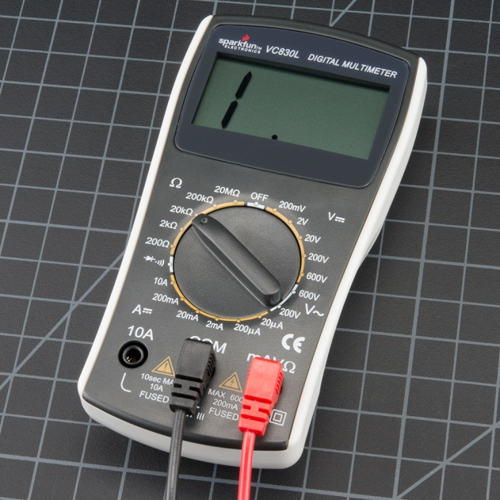

The Selection Knob Panel:

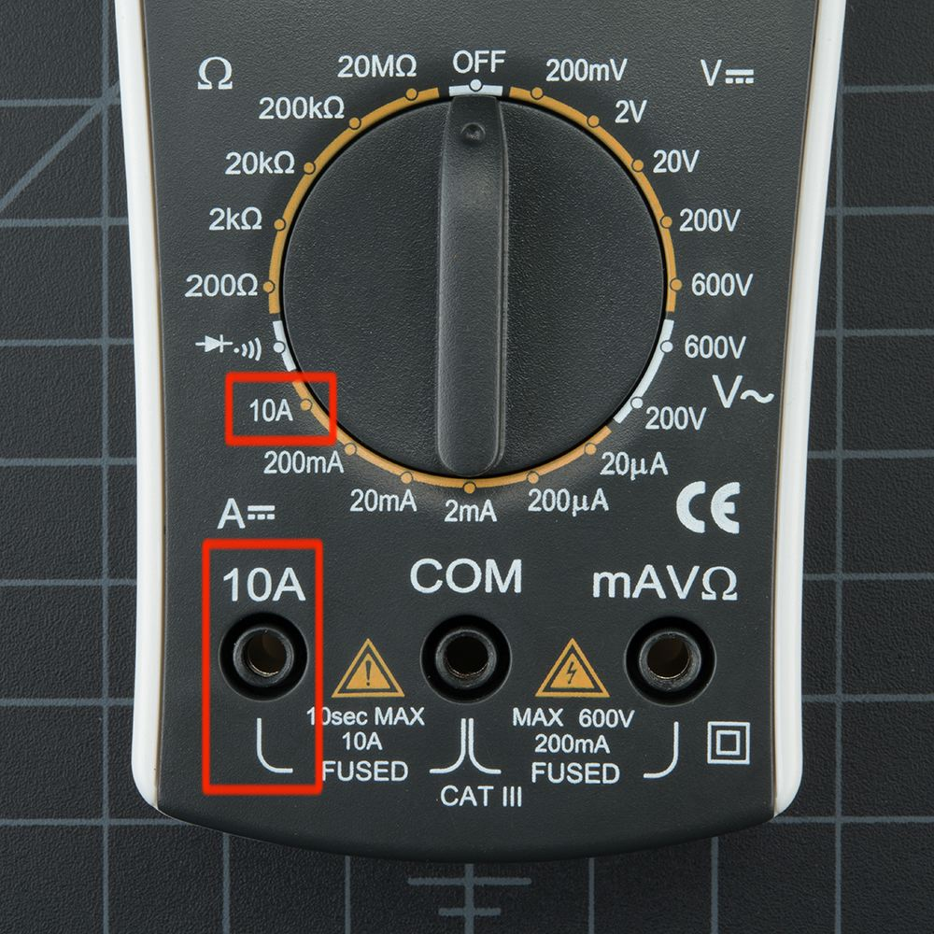

**IN BREIF:**

As seen in the picture, we have different ohmic ranges towards left top,

Then on the left side we have the *“diode and sound like”* symbol that is used to measure continuity in electrical components….

Current ranges downwards (different port plugging required for mA and A)

Towards the Right Top we have different voltage ranges (used for measuring DC voltage)

Towards Right Bottom we have the Ac Voltage Symbol “ V*~ ”* . The multimeter can meaure Average Value of Ac Voltage

**COM** stands for common and is almost always connected to Ground or ‘-’ of a circuit.

PROBES

Your multimeter probably came with red and black wires that look something like the ones in Figure 4. These wires are called **probes** or **leads** (pronounced "leeds"). One end of the lead is called a **banana jack**; this end plugs into your multimeter (*Note:* some multimeters have **pin jacks**, which are smaller than banana jacks; if you need to buy replacement probes, be sure to check your multimeter's manual to find out which kind you need).

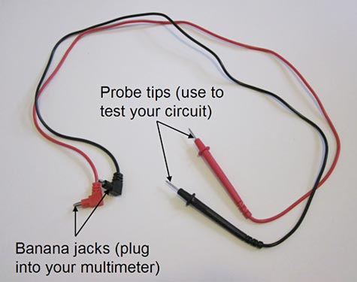  
**Figure 4.** A typical pair of multimeter probes.

**VOLTAGE MEASUREMENT:**

#For basic measurement of Voltage and Resistance probes must be plugged into the COM and mAV_()_ port ….(irrespective of color although black is preferred for COM(ground) while red is preferred for the other one)

#The Voltage is measured in a way similar to a voltmeter that is in parallel to the component

#The red probe is connected to the component with positive side polarity while COM on the other side.

#If you select a voltage setting that is too low for the voltage The meter will simply display a 1. This is the meter trying to tell you that it is overloaded or out-of-range. Whatever you’re trying to read is too much for that particular setting. Try changing the multimeter knob to the next highest setting.

#if too high, then meter displays a “0.00... “Reading, try switching to the next lower reading.

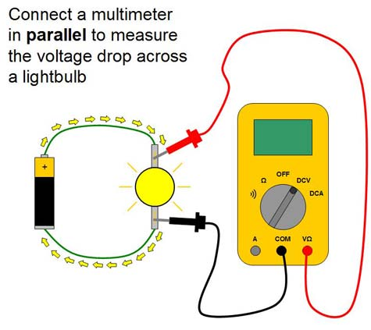

**Measuring Resistance**

#Separately take the resistors (disconnected from the circuits) and connect the probes across them, setting the correct ohmic range on the knob , the resistance value is displayed.

#Multimeter sends some current in the resistor and hence obtains its value.

#If the multimeter **reads 1** or displays **OL**, it’s overloaded. You will need to try a higher mode such as **200kΩ** mode or **2MΩ** (mega-ohm) mode. There is no harm if this happen, it simply means the range knob needs to be adjusted.

#If the multimeter reads **0.00** or nearly zero, then you need to lower the mode to **2kΩ** or **200Ω**.

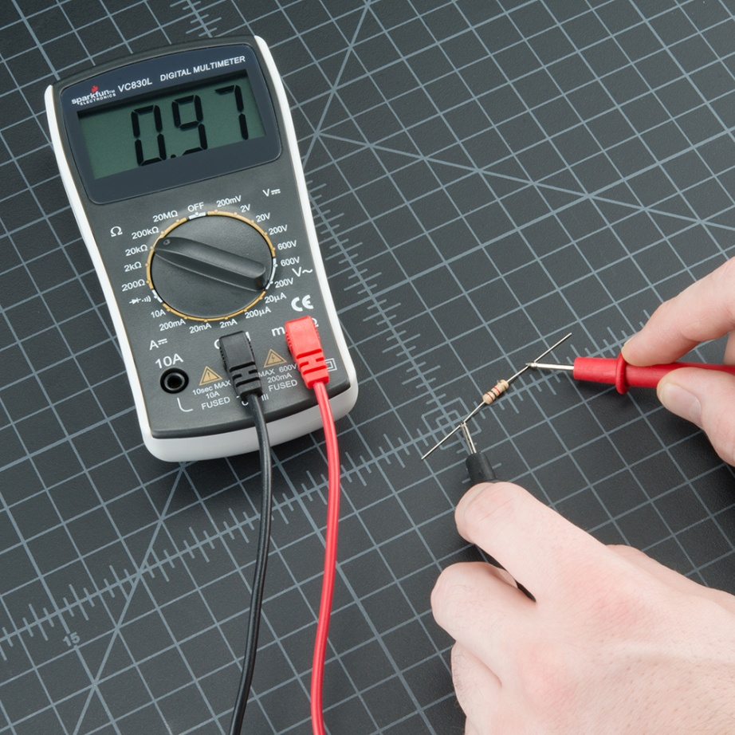

**Measuring Current**

Current is measured in a way similar to an ammeter, by breaking the circuit and connecting the multimeter in series with the circuit. Firstly we must know whether our current value will turn out to be in smaller values(mA) or larger values(up to 10A(max)) ,this is for selection of probe port. If values are too large(in A) then shift the red probe from mAV_()_ (left) to A(right).

Then shift the knob to proper current ranges and hence measure the value of current flowing in the circuit.

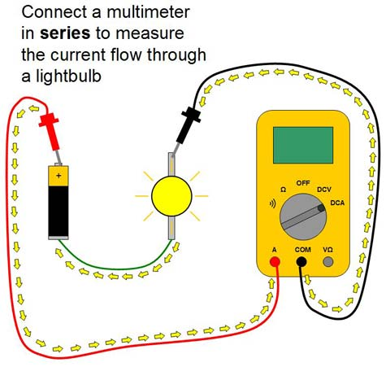

**Continuity**

Connected the probes across the terminals that you need to check for the continuity, move the knob to the “diode and sound symbol”. If you hear a beep there is continuity not else wise.

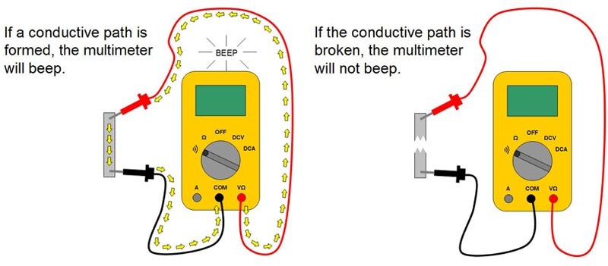

DIODE CHECK:

Similar to resistor,take separately the diode , move the knob to the diode symbol and connect COM to cathode(with white stripe) of diode while Positive(RED) probe to anode then it shows the Diode Voltage, if opposite connections are given , then overload occurs and “1” is displayed.

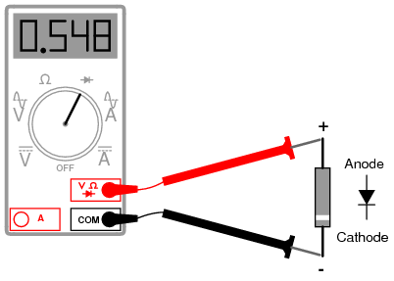

REF:

<https://www.electronics-notes.com/articles/test-methods/meters/how-to-measure-current.php>

SparkFun

YouTube

**SWITCHES**

MECHANICAL SWITCHES

Based on the number of poles and throws, switches are classified into following types. The **pole** represents the number of individual power circuits that can be switched. Most of the switches are designed have one, two or three poles and are designated as single pole, double pole and triple pole.

The number of **throws** represents the number of states to which current can pass through the switch. Most of the switches are designed to have either one or two throws which are designated as single throw and double throw switches.

**Single Pole Single Throw Switch (SPST)**

* [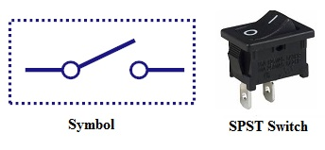](https://www.electronicshub.org/wp-content/uploads/2015/09/1-1.jpg)[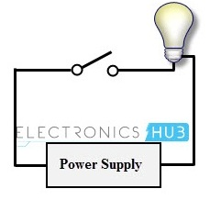](https://www.electronicshub.org/wp-content/uploads/2015/09/single-pole-single-throw-example.jpg)This is the basic ON and OFF switch consisting of one input contact and one output contact.
* It switches a single circuit and it can either make (ON) or break (OFF) the load.
* The contacts of SPST can be either normally open or normally closed configurations .

**Single Pole Double Throw Switch (SPDT)**

* [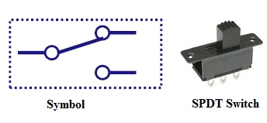](https://www.electronicshub.org/wp-content/uploads/2015/09/SPDT-Switch.jpg)[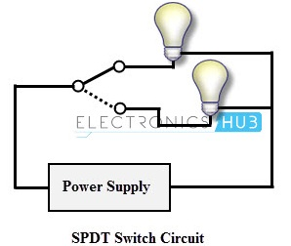](https://www.electronicshub.org/wp-content/uploads/2015/09/SPDT-exmaple.jpg)This switch has three terminals, one is input contact and remaining two are output contacts.
* This means it consist two ON positions and one OFF position.
* In most of the circuits, these switches are used as changeover to connect the input between two choices of outputs.
* The contact which is connected to the input by default is referred as normally closed contact and contact which will be connected during ON operation is a normally open contact.

**Double Pole Single Throw Switch (DPST)**

[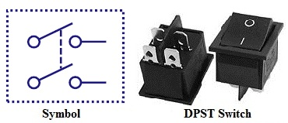](https://www.electronicshub.org/wp-content/uploads/2015/09/DPST-Switch.jpg)

* [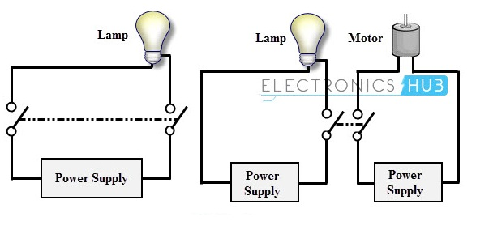](https://www.electronicshub.org/wp-content/uploads/2015/09/Dpst-example.jpg)This switch consists of four terminals,two input contacts and two output contacts.
* It behaves like a two separate SPST configurations, operating at the same time.
* It has only one ON position, but it can actuate the two contacts simultaneously, such that each input contact will be connected to its corresponding output contact.
* In OFF position both switches are at open state.
* This type of switches is used for controlling two different circuits at a time.
* Also, the contacts of this switch may be either normally open or normally closed configurations.

**Double Pole Double Throw Switch (DPDT)**

[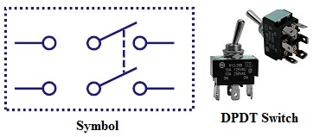](https://www.electronicshub.org/wp-content/uploads/2015/09/DPDTSwitch.jpg)

* [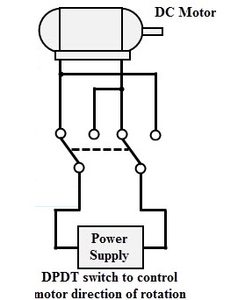](https://www.electronicshub.org/wp-content/uploads/2015/09/DPDT-Example.jpg)This is a dual ON/OFF switch consisting of two ON positions.
* It has six terminals,two are input contacts and remaining four are the output contacts.
* It behaves like a two separate SPDT configuration, operating at the same time.
* Two input contacts are connected to the one set of output contacts in one position and in another position, input contacts are connected to the other set of output contacts.

**Push Button Switch**

* [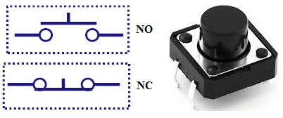](https://www.electronicshub.org/wp-content/uploads/2015/09/PushButton.jpg)It is a momentary contact switch that makes or breaks connection as long as pressure is applied (or when the button is pushed).
* Generally, this pressure is supplied by a button pressed by someone’s finger.
* This button returns its normal position, once the pressure is removed.
* The internal spring mechanism operates these two states (pressed and released) of a push button.
* It consists of stationary and movable contacts, of which stationary contacts are connected in series with the circuit to be switched while movable contacts are attached with a push button.
* Push buttons are majorly classified into normally open, normally closed and double acting push buttons as shown in the above figure.
* Double acting push buttons are generally used for controlling two electrical circuits.

**Toggle Switch**

[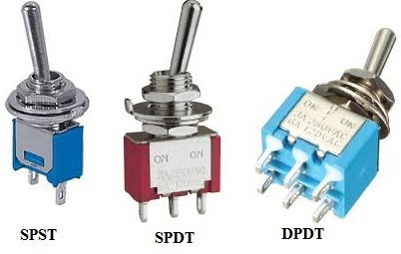](https://www.electronicshub.org/wp-content/uploads/2015/09/ToggleSwitch.jpg)

* A toggle switch is manually actuated (or pushed up or down) by a mechanical handle, lever or rocking mechanism. These are commonly used as light control switches.
* Most of these switches come with two or more lever positions which are in the versions of SPDT, SPST, DPST and DPDT switch. These are used for switching high currents (as high as 10 A) and can also be used for switching small currents.
* These are available in different ratings, sizes and styles and are used for different type of applications. The ON condition can be any of their level positions, however, by convention the downward is the closed or ON position.

**Limit Switch**

* [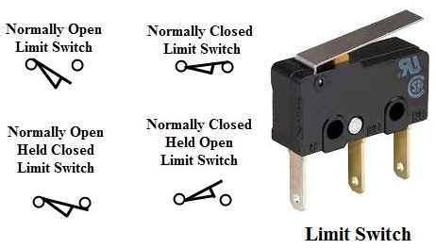](https://www.electronicshub.org/wp-content/uploads/2015/09/Limit-Switch-1.jpg)
* The control schemes of a limit switch are shown in above figure , in which four varieties of limit switches are presented.
* Some switches are operated by the presence of an object or by the absence of objects or by the motion of machine instead of human hand operation. These switches are called as limit switches.
* These switches consist of a bumper type of arm actuated by an object. When this bumper arm is actuated, it causes the switch contacts to change position.

**Float Switches[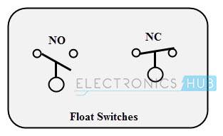](https://www.electronicshub.org/wp-content/uploads/2015/09/Float-Switches.jpg)**

* Float switches are mainly used for controlling DC and AC motor pumps according to the liquid or water in a tank or sump.
* This switch is operated when the float (or floating object) moves downward or upward based on water level in a tank.
* This float movement of rod or chain assembly and counterweight causes to open or close electrical contacts. Another form of float switch is the mercury bulb type switch that does not consist of any float rod or chain arrangement.
* This bulb consist of mercury contacts such that when the liquid level rises or falls, the state of contacts also changes.
* The ball float switch symbol is shown in the above figure. These float switches can be normally open or normally closed type.

**Flow Switches**

[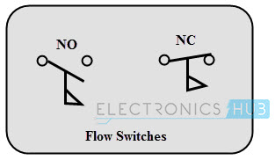](https://www.electronicshub.org/wp-content/uploads/2015/09/Flow-Switches.jpg)

* These are mainly used to detect the movement of liquid or air flow through a pipe or duct. The air flow switch (or a micro switch) is constructed by a snap-action.
* This micro switch is attached to a metal arm .To this metal arm, a thin plastic or metal piece is connected.
* When a large amount of air passes through the metal or plastic piece, it causes the movement of metal arm and thus operates the contacts of the switch.
* Liquid flow switches are designed with a paddle that inserted across the flow of liquid in a pipe. When liquid flows through the pipe, force exerted against the paddle changes the position of the contacts.
* The above figure shows the switch symbol used for both air flow and liquid flow. The flag symbol on the switch indicates the paddle which senses the flow or movement of liquid.
* These switches again normally open or normally closed type configurations.

**Pressure Switches**

[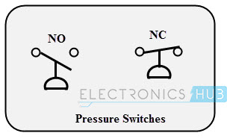](https://www.electronicshub.org/wp-content/uploads/2015/09/Pressure-Switches.jpg)

* These switches are commonly used in industrial applications in order to sense the pressure of hydraulic systems and pneumatic devices.
* Depends on the range of pressure to be measured, these pressure switches are classified into diaphragm operated pressure switch, metal bellow type pressure switch and piston type pressure switch.
* In all these types, pressure detection element operates a set of contacts (which can be either double pole or single pole contacts).
* This switch symbol consist a half-circle connected to a line in which flat part indicates a diaphragm. These switches may be either normally open or normally closed type configurations.

**Temperature Switches**

[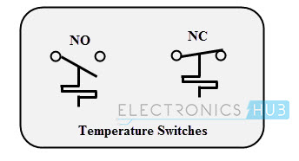](https://www.electronicshub.org/wp-content/uploads/2015/09/Temperature-sensors.jpg)

* The most common heat sensing element is the bimetallic strip that operates on the principle of thermal expansion.
* The bimetallic strips are made with two dissimilar metals (that are having different thermal expansion rates) and are bonded with each other.
* The switch contacts are operated when the temperature causes the strip to bend or wrap. Another method of operating the temperature switch is to use mercury glass tube.
* When the bulb is heated, mercury in the tube will expand and then generates pressure to operate the contacts.

**Joystick Switch**

[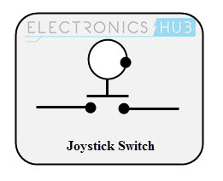](https://www.electronicshub.org/wp-content/uploads/2015/09/Joystick-Switch.jpg)

* Joystick switches are manually actuated control devices used mainly in portable control equipments.
* It consists of a lever which moves freely in more than one axis of motion.
* Depending on the movement of the lever pushed, one or more switch contacts are actuated.
* These are ideally suited for lowering, raising and triggering movements to the left and right.
* These are used for building machinery, cable controls and cranes. The symbol for the joystick is shown below.

**Rotary Switches**

[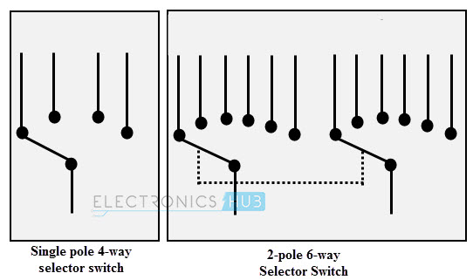](https://www.electronicshub.org/wp-content/uploads/2015/09/Selector-Switch.jpg)

* These are used for connecting one line to one of many lines.
* Examples of these switches are range selectors in electrical metering equipment, channel selectors in communication devices and band selectors in multi-band radios.
* It consists of one or more moving contacts (knob) and more than one stationary contact.
* These switches are come with different arrangement of contacts such as single pole 12-way, 3-pole 4-way, 2-pole 6-way and 4-pole 3-way.

**Electronic Switches**

The electronic switches are generally called as solid state switches because there are no physical moving parts and hence absence of physical contacts. Most of the appliances are controlled by semiconductor switches such as motor drives and HVAC equipments.

There are different types of solid state switches are available in today market with different sizes and ratings. Some of these solid state switches include transistors, SCRs, MOSFETs, TRIACs and IGBTs.

**Bipolar Transistors**

A transistor either allows the current to pass or it blocks the current as similar to working of normal switch.

In switching circuits, transistor operates in cut-off mode for OFF or current blocking condition and in saturation mode for ON condition. The active region of the transistor is not used for switching applications.

[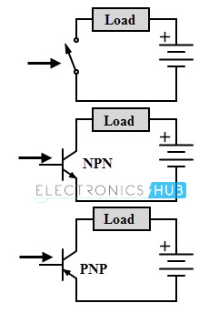](https://www.electronicshub.org/wp-content/uploads/2015/09/Transistor.jpg)

Both NPN and PNP transistors are operated or switched ON when a sufficient base current is supplied to it. When a small current flows though the base terminal supplied by a driving circuit (connected between the base and emitter), it causes to turns ON the collector-emitter path.

And it is turned OFF when the base current is removed and base voltage is reduced to a slight negative value. Even though it utilizes small base current, it is capable to carry much higher currents through the collector- emitter path.

[**Power Diode**](https://www.electronicshub.org/power-diodes-and-rectifiers/)

A diode can perform switching operations between its high and low state impedance states. Semiconductor materials like silicon and germanium are used for constructing the diodes.

Usually, power diodes are constructed using silicon in order to operate the device at higher currents and higher junction temperatures. These are constructed by joining p and n type semiconductor materials together to form PN junction. It has two terminals namely anode and cathode.

[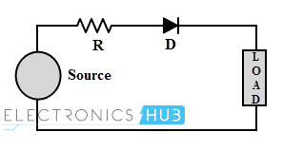](https://www.electronicshub.org/wp-content/uploads/2015/09/Diode.jpg)

When the anode is made positive with respect to cathode and by the application of voltage greater than the threshold level, PN junction is forward biased and starts conducting (like ON switch). When the cathode terminal is made positive with respect to anode, PN junction reverse biased and its blocks the current flow (like OFF switch).

**MOSFET**

Metal Oxide Semiconductor Field Effect Transistor ([MOSFET](https://www.electronicshub.org/mosfet/)) is a unipolar and high frequency switching device. It is a most commonly used switching device is power electronic applications. It has three terminals namely drain (output), source (common) and gate (input).

It is a voltage controlled device, i.e., by controlling input (gate to source) voltage, resistance between the drain and source is controlled which further determines the ON and OFF state of the device.

[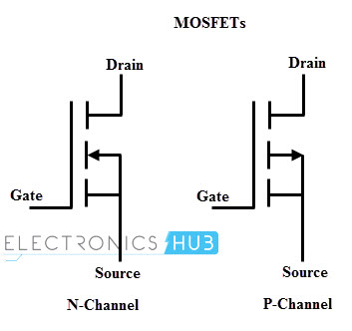](https://www.electronicshub.org/wp-content/uploads/2015/09/MOSFET.jpg)

MOSFETs can be a P-channel or N-channel devices. The N-channel MOSFET is tuned ON by applying a positive VGS with respect to the source (provided that VGS should be greater than threshold voltage).

P-channel MOSFET operates in a similar manner of N-channel MOSFET but it uses reverse polarity of voltages. Both VGS and VDD are negative with respect the source to switch ON the P- channel MOSFET.

**IGBT**

IGBT (Insulated Gate Bipolar Transistor) combines the several advantages of bipolar junction power transistor and power MOSFET. Like a MOSFET, it is a voltage controlled device and has lower ON state voltage drop (less than that of MOSFET and closer to power transistor).

It is a three terminal semiconductor high speed switching device. These terminals are emitter, collector and gate.

[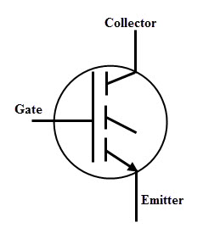](https://www.electronicshub.org/wp-content/uploads/2015/09/IGBT.jpg)

Similar to the MOSFET, IGBT can be turned ON by applying a positive voltage (greater than the threshold voltage) between the gate and emitter. IGBT can be turned by reducing the voltage across the gate-emitter to zero. In most of the case it needs negative voltage to reduce turn OFF losses and safely turn OFF the IGBT.

**SCR**

A Silicon Controlled Rectifier ([SCR](https://www.electronicshub.org/silicon-controlled-rectifier/)) most widely used high speed switching device for power control applications. It is a unidirectional device as a diode, consisting of three terminals, namely anode, cathode and gate.

An SCR is turned ON and OFF by controlling its gate input and biasing conditions of the anode and cathode terminals. SCR consists of four layers of alternate P and N layers such that boundaries of each layer forms junctions J1, J2 and J3.

[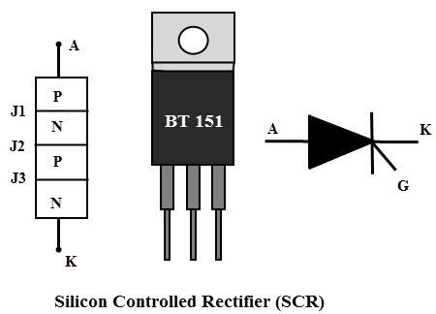](https://www.electronicshub.org/wp-content/uploads/2015/09/SCR.jpg)

**TRIAC**

[Triac](https://www.electronicshub.org/triac/) (or TRIode AC) switch is a bidirectional switching device which is an equivalent circuit of two back to back SCRs connection with one gate terminal.

Its capability to control AC power in both positive and negative peaks of the voltage waveform often makes these devices to be used in motor speed controllers, light dimmers, pressure control systems, motor drives and other AC control equipments.

[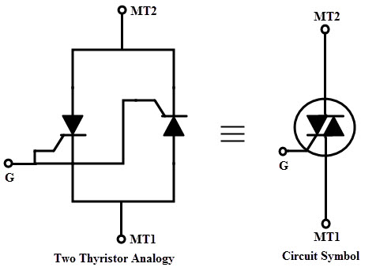](https://www.electronicshub.org/wp-content/uploads/2015/09/14.jpg)

**DIAC**

A [DIAC](https://www.electronicshub.org/diac/) (or DIode AC switch) is bidirectional switching device and it consists of two terminals which are not named as anode and cathode. It means that a DIAC can be operated in either direction regardless of the terminal identification. This indicates that the DIAC can be used in either direction.

[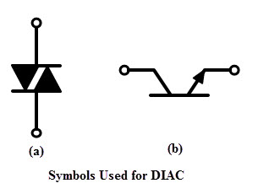](https://www.electronicshub.org/wp-content/uploads/2015/09/Symbols-Used-for-DIAC.jpg)

When a voltage is applied across a DIAC, it either operates in forward blocking or reverse blocking mode unless the applied voltage is less than the breakover voltage. Once the voltage is increased more than breakover voltage, avalanche breakover occurs and device starts conducting.

**Gate Turn-Off Thyristor**

A GTO ([Gate Turn off Thyristor](https://www.electronicshub.org/gate-turn-off-thyristor/)) is a bipolar semiconductor switching device. It has three terminals as anode, cathode and gate. As the name implies, this switching device is capable to turn OFF through gate terminal.

A GTO is turned ON by applying a small positive gate current triggers the conduction mode and turned OFF by a negative pulse to the gate. GTO symbol consists of double arrows on the gate terminal which represents the bidirectional flow of current through gate terminal.

[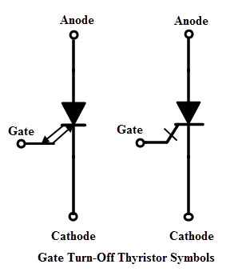](https://www.electronicshub.org/wp-content/uploads/2015/09/GTO-Symbols.jpg)

**CONNECTORS**

Introduction

Connectors are used to join subsections of circuits together. Usually, a connector is used where it may be desirable to disconnect the subsections at some future time: power inputs, peripheral connections, or boards which may need to be replaced.

Connector Terminology

**Gender** - The gender of a connector refers to whether it plugs in or is plugged into and is typically male or female, respectively

[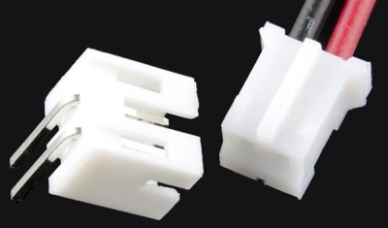](https://cdn.sparkfun.com/assets/2/6/0/7/f/51141810ce395f4d7e000007.jpg)

*Male (left) and female 2.0mm PH series JST connectors. In this case, gender is determined by the individual conductor.*

**Polarity** - Most connectors can only be connected in one orientation. This trait is called polarity, and connectors which have some means to prevent them being connected wrong are said to be **polarized**, or sometimes **keyed**.

[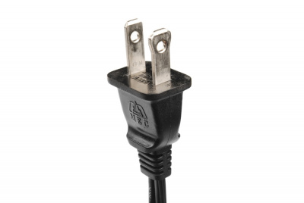](https://cdn.sparkfun.com/assets/5/1/0/d/c/51154c1cce395f903d000001.jpg)

*A polarized North American wall plug. By having two different widths for the plug blades, the plug will only go into the outlet one way.*

**Contact** - Contacts are the business portion of the connector. They are the metal parts which touch each other, forming an electrical connection. This is also where problems occur: the contacts can become soiled or oxidized, or the springiness required to hold the contacts together may fade with time.

[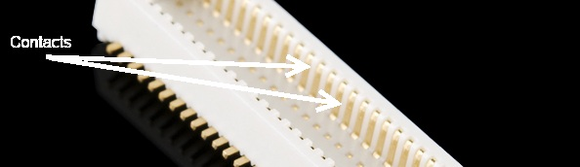](https://cdn.sparkfun.com/assets/7/4/d/c/6/511414a4ce395f337e000007.jpg)

*The contacts on this connector are clearly visible.*

**Pitch** - Many connectors consist of an array of contacts in a repeated pattern. The pitch of the connector is the distance from the center of one contact to the center of the next. This is important, because there are many families of contacts which look very similar but may differ in pitch, making it difficult to know that you are purchasing the right mating connector[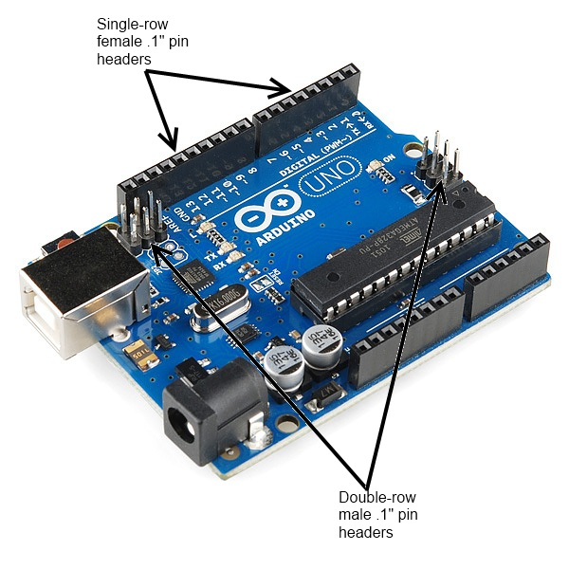](https://cdn.sparkfun.com/assets/b/c/9/7/1/5148c334ce395f8e55000000.jpg)

*The pitch of the pins on the headers on a standard Arduino is .1".*

**Mating cycles** - Connectors have a finite life, and connecting and disconnecting them is what wears them out. Datasheets usually present that information in terms of **mating cycles**, and it varies widely from one technology to another. A USB connector may have a lifetime in the thousands or tens of thousands of cycles, while a board-to-board connector designed for use inside of consumer electronics may be limited to tens of cycles. It’s important that you select a connector with a suitable life for the application.

[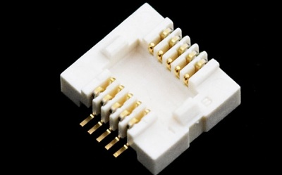](https://cdn.sparkfun.com/assets/9/1/d/b/b/51141922ce395fd17d00000a.jpg)

[*Mating connector*](https://www.sparkfun.com/products/9079)*for the GS406 GPS module. The*[*connector’s datasheet*](http://www.sparkfun.com/datasheets/GPS/Modules/SPK-GPS-GS406-1R.pdf)*indicates a maximum of 50 insertion cycles for this part.*

**Mount** - This one has the potential for being confusing. The term “mount” can refer to several things: how the connector is mounted in use (panel mount, free-hanging, board mount), what the angle of the connector is relative to its attachment (straight or right-angle), or how it is mechanically attached (solder tab, surface mount, through hole). We’ll discuss this more in the examples section for each individual connector.

[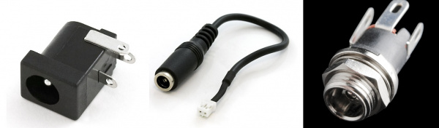](https://cdn.sparkfun.com/assets/b/5/4/1/6/51140d09ce395f697e000003.jpg)

*A comparison of three different methods of mounting the same barrel connector: (left to right) board mount, inline cable mount, and panel mount.*

**Strain relief** - When a connector mounts to a board or cable, the electrical connections tend to be somewhat fragile. It is typical to provide some kind of strain relief to transfer any forces acting on that connector to a more mechanically sound object than the fragile electrical connections. Again, there will be some good examples of this later on.

[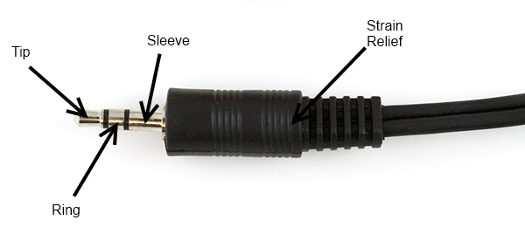](https://cdn.sparkfun.com/assets/c/a/3/6/6/5113dc95ce395fe501000000.png)

*This 1/8" headphone jack comes with a strain relief “boot” slid over the cable to prevent forces on the cable from being transmitted directly to the electrical joints.*

**USB Connectors**

**USB connectors** come in two flavors: host and peripheral. In the USB standard, there is a difference between the two, and the connectors on cables and devices reflect this. However, all USB connectors will have some things in common:

* **Polarization** - A USB connector can only nominally be inserted one way. It may be possible to force a connector in wrong, but that *will* result in damage to the device.
* **Four contacts** - All USB connectors have at least four contacts (although some may have five, and [USB 3.0](http://en.wikipedia.org/wiki/USB_3.0)connectors have even more). These are for power, ground, and two data lines (D+ and D-). USB connectors are designed to transmit 5V, up to 500mA.
* **Shielding** - USB connectors are shielded, such that a metal shell which is not part of the electrical circuit is provided. This is important to keep the signal intact in environments with a lot of electrical “noise”.
* **Robust power connection** - It’s important for the power pins to make connection before the data lines, to avoid trying to power the device over the data lines. All USB connectors are designed with this in mind.
* **Molded strain relief** - All USB cables have plastic overmolding at the connector to prevent strain on the cable that could potentially damage the electrical connections.

[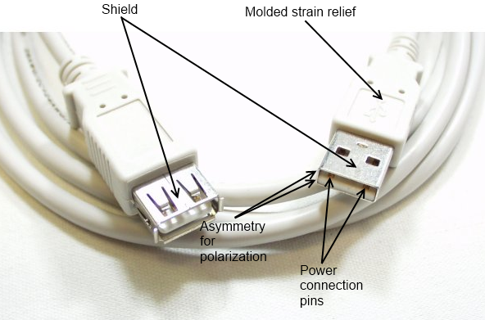](https://cdn.sparkfun.com/assets/e/4/c/4/b/5112e967ce395fc826000002.png)

*A*[*USB extension cable*](https://www.sparkfun.com/products/518)*, with some of the common features of USB connectors labeled.*

USB-A Connectors

**USB-A female** is the standard “host” connector type. This is found on computers, hubs, or any device intended to have peripherals plugged into it. It is also possible to find extension cables with a female A connector and a male A connector on the other end.

[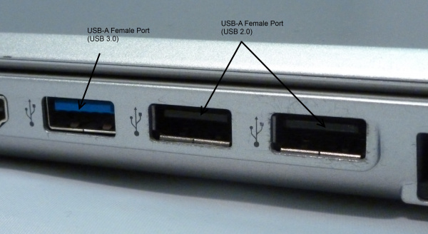](https://cdn.sparkfun.com/assets/6/2/0/e/3/5113cf7fce395fb17e000000.JPG)

***Female USB-A****ports on the side of a laptop. The blue connector is USB 3.0 compliant.*

**USB-A male** is the standard “peripheral” connector type. Most USB cables will have one end terminating in a USB-A male connector, and many devices (such as keyboards and mice) will have a built-in cable terminated with a USB-A male connector. It’s also possible to find USB-A male connectors that are board mountable, for devices like USB memory sticks.

[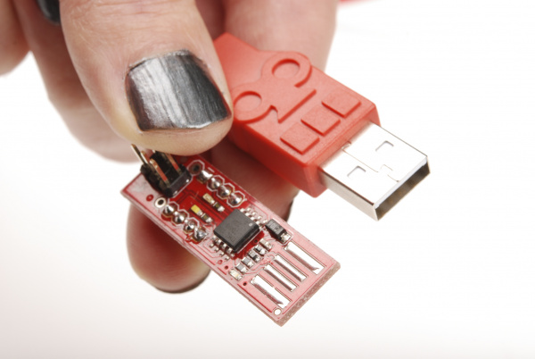](https://cdn.sparkfun.com/assets/2/a/f/d/4/51154e04ce395f6140000005.jpg)

*Two types of****Male USB-A****connectors, on a*[*SparkFun Cerberus cable*](https://www.sparkfun.com/products/11515)*and an*[*AVR Stick*](https://www.sparkfun.com/products/9147)*development board.*

USB-B Connectors

**USB-B female** is a standard for peripheral devices. It’s bulky, but robust, so in applications where size is not an issue, it’s the preferred means for providing a removable connector for USB connectivity. It is usually a through-hole board mount connector, for maximum reliability, but there are panel-mount options for it as well.

[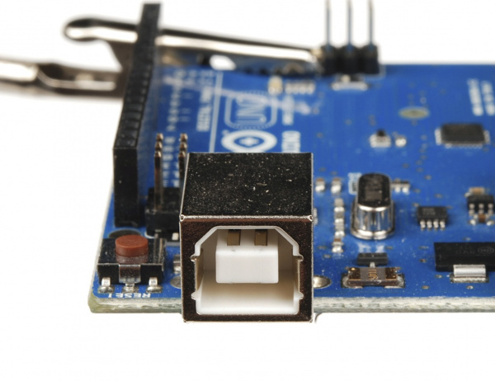](https://cdn.sparkfun.com/assets/5/3/d/3/b/5113e953ce395fbf7d000007.JPG)

*Arduino boards, including this*[*Uno*](https://www.sparkfun.com/products/11224)*, have long used the female****USB-B****connector, due to its low cost and durability.*

**USB-B male** is almost exclusively found at the end of a cable. USB-B cables are ubiquitous and inexpensive, which also contributes to the popularity of the USB-B connection.

[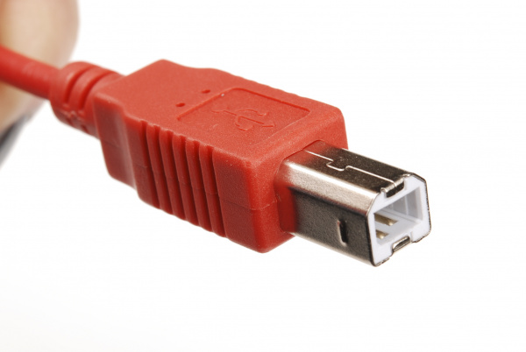](https://cdn.sparkfun.com/assets/f/7/4/a/7/51154e0ece395fee3f000002.jpg)

*USB-B male* connector on the end of a [SparkFun Cerberus cable](https://www.sparkfun.com/products/11515).

USB-Mini Connectors

The **USB-Mini** connection was the first standard attempt to reduce the size of the USB connector for smaller devices. USB-Mini female is typically found on smaller peripherals (MP3 players, older cellphones, small external hard drives), and is usually a surface mount connector, trading robustness for size. USB-Mini is slowly being phased out in favor of the USB-Micro connector.

[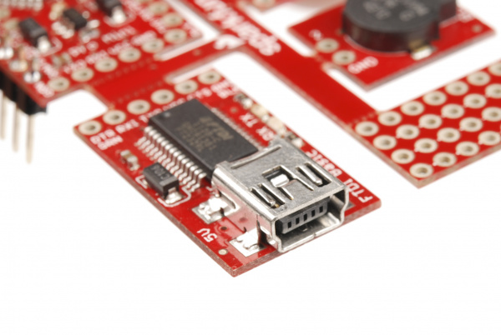](https://cdn.sparkfun.com/assets/8/e/e/9/0/51154e0ece395f0440000004.jpg)

***USB-Mini female****connector on a*[*Protosnap Pro Mini*](https://www.sparkfun.com/products/10889)*.*

**USB-Mini male** is another cable-only connector. As with USB-B, it’s extremely common, and cables can be found cheaply almost anywhere.

[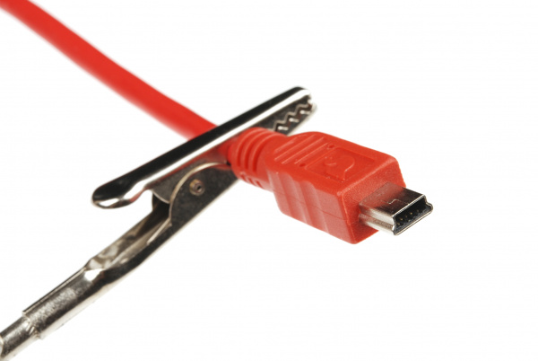](https://cdn.sparkfun.com/assets/e/a/2/5/3/5113e5f8ce395faa7d000004.JPG)

***USB-Mini male****connector on the end of a*[*SparkFun Cerberus cable*](https://www.sparkfun.com/products/11515)*.*

USB-Micro Connectors

**USB-Micro** is a fairly recent addition to the USB connector family. As with USB-Mini, the primary concern is size reduction, but USB-Micro adds a fifth pin for low-speed signalling, allowing it to be used in USB-OTG (On-the-go) applications where a device may want to operate as either a host or a peripheral depending on circumstances.

**USB-Micro female** is found on many newer peripherals, such as digital cameras and MP3 players. The adoption of USB-micro as a standard charge port for all new cellular phones and tablet computers means that chargers and data cables are becoming increasingly common, and USB-Micro is likely to supplant USB-Mini in the coming years as the small-factor USB connector of choice.

[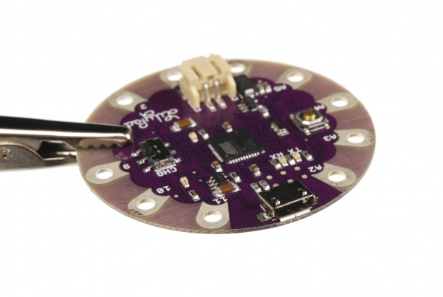](https://cdn.sparkfun.com/assets/0/d/8/8/5/5113e6a5ce395f1c7e000000.JPG)

***USB-Micro female****connector on a*[*LilyPad Arduino USB*](https://www.sparkfun.com/products/11190)*board.*

**USB-Micro male** is also a cable-only connector. There are generally two types of cables with USB-Micro male ends: one for connecting a device with a USB-Micro port as a peripheral to a USB host device and one for adapting the USB-Micro female port to a USB-A female port, to be used in USB-OTG capable devices.

[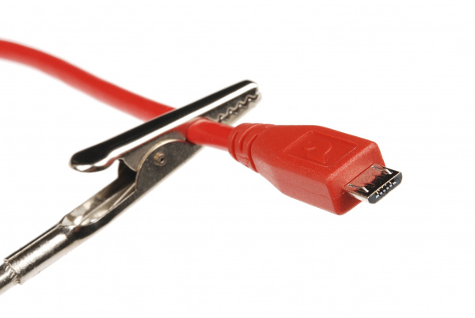](https://cdn.sparkfun.com/assets/b/5/c/0/c/5113e63fce395ffe7d000000.JPG)

***USB-Micro male****connector on the*[*SparkFun Cerberus cable*](https://www.sparkfun.com/products/11515)*.*

[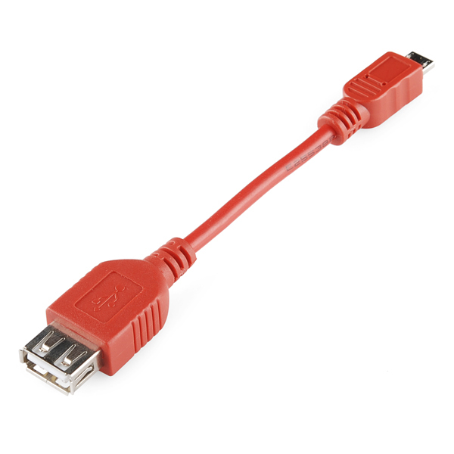](https://cdn.sparkfun.com/assets/2/7/d/4/f/5113e730ce395f8d7e000000.jpg)

[*Adapter pigtail*](https://www.sparkfun.com/products/11604)*for using USB-OTG capable devices having only a USB-Micro port with standard USB peripherals. Note that not all devices supporting USB-OTG will work with this pigtail.*

Audio Connectors

Another familiar connector group are those used for audio-visual applications–RCA and phono. While these can’t truly be considered to be of the same family, as the various USB connectors are, we’ll consider both of them to be in the same vein.

“Phone” Type Connectors

You’ll probably immediately recognize the 1/8" version of this connector as a the plug on the end of a pair of headphones. These connectors actually come in three common sizes: ¼" (6.35mm), 1/8" (3.5mm), and 2.5mm. ¼" size connectors find a lot of use in the professional audio and music community- most electric guitars and amplifiers have ¼" tip-sleeve (TS) jacks on them. 1/8" tip-ring-sleeve (TRS) is very common as the connector for headphones or audio output signals on MP3 players or computers. Some cell phones will provide a 2.5mm tip-ring-ring-sleeve (TRRS) jack for connecting to headphones that also include a microphone for hands-free communications.

The common availability of these connectors and cables makes them a good candidate for general purpose connectivity applications–for instance, long before USB, [Texas Instruments graphing calculators](http://en.wikipedia.org/wiki/TI-85) used a 2.5mm TRS connector for a serial programming connector. It should be remembered that tip-sleeve connector types are not designed for carrying power; during insertion, the tip and the sleeve can be momentarily shorted together, which may damage the power supply. The lack of shielding makes them poor candidates for high-speed data, but low speed serial data can be passed through these connectors.

[](https://cdn.sparkfun.com/assets/c/a/3/6/6/5113dc95ce395fe501000000.png)

[*Headphone-type TRS phone plug, 1/8"*](https://www.sparkfun.com/products/11143)*. Typically, tip and ring will carry the stereo audio signals while sleeve will be connected to ground.*

[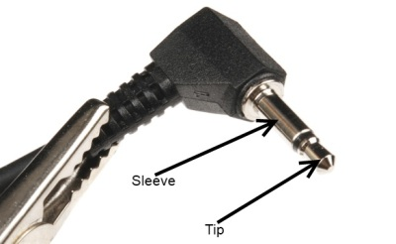](https://cdn.sparkfun.com/assets/9/a/9/8/3/51141b22ce395f657e000006.jpg)

*1/8" phone plug. Note the lack of a ring contact on this connector.*

[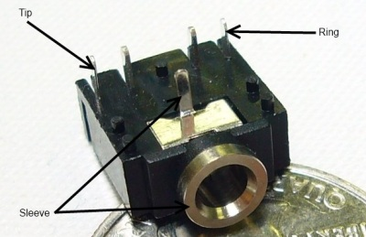](https://cdn.sparkfun.com/assets/7/3/1/d/6/51141ba3ce395f337e000008.jpg)

[*1/8" board mount headphone jack*](https://www.sparkfun.com/products/8032)*with pins corresponding pin connections labeled. When no jack is inserted, an internal switch connects the tip and ring pins to the adjacent unmarked pins, allowing insertion detection.*

RCA Connectors

Familiar as the home-stereo connector of choice for many decades, the RCA connector was introduced in the 1940s by RCA for home phonographs. It is slowly being supplanted by connections like HDMI in the audio-visual realm, but the ubiquity of the connectors and cables makes it a good candidate for home-built systems. It will be a long time before it is obsolete.

Female RCA connectors are usually found on devices, although it is possible to find extension or conversion cables with female jacks on them. Most RCA connectors are connected to one of four types of signals: component video (PAL or NTSC, depending on where the equipment was sold), composite video, stereo audio, or S/PDIF audio.

[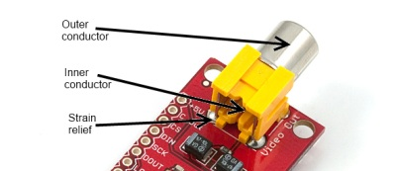](https://cdn.sparkfun.com/assets/8/1/0/1/4/51141d1ace395fff7d000005.jpg)

[*Female RCA connector*](https://www.sparkfun.com/products/8631)*, for video signals. Typically, NTSC or PAL video signal connectors will be yellow.*

Male RCA connectors are usually found on cables.

[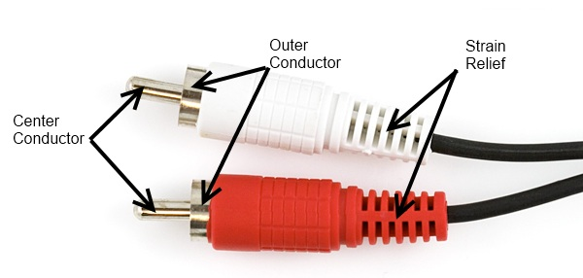](https://cdn.sparkfun.com/assets/f/c/9/7/4/5113df13ce395f0f7e000000.jpg)

[*Male RCA plugs*](https://www.sparkfun.com/products/8919)*. Red and white are usually for audio applications, with red denoting the “right” audio channel.*

Power Connectors

While many connectors carry power in addition to data, some connectors are used specifically to provide power connections to devices. These vary widely by application and size, but we will only focus on some of the most common ones here.

Barrel Connectors

Barrel connectors are typically found on low-cost consumer electronics which can be plugged into wall power via bulky [AC wall adaptors](https://www.sparkfun.com/products/8269?). Wall adaptors are widely available, in a variety of power ratings and voltages, making barrel connectors a common means for connecting power to small projects.

The female barrel connector, or “jack”, can be purchased in several varieties: PCB mounted (surface mount or through hole), cable mount, or panel mount. Some of these connectors will have an additional contact that allows the application to detect whether a power supply is plugged into the barrel jack or not, thus allowing the device to bypass batteries and save battery life when running on external power.

[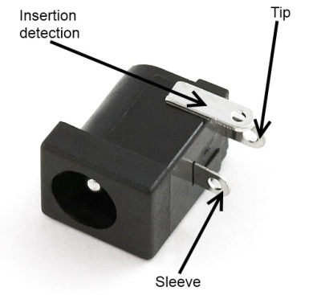](https://cdn.sparkfun.com/assets/a/6/c/e/3/51141da0ce395fe67e000005.jpg)

[*Female barrel connector*](https://www.sparkfun.com/products/119)*. When no plug is inserted, the “insertion detection” pin will be shorted to the “sleeve” pin.*

The male barrel connector, or “plug”, is usually only found in a wire termination variety, although there are multiple methods of attaching the plug to the end of the wire. It’s also possible to get plugs that come pre-attached to a cable.

[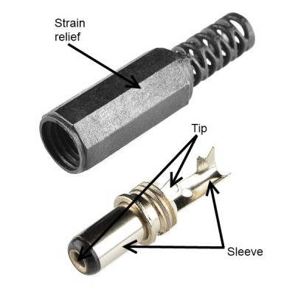](https://cdn.sparkfun.com/assets/e/b/d/c/3/51141dfdce395fe801000002.jpg)

[*Unattached male barrel plug*](https://www.sparkfun.com/products/11476)*, for attachment to any power supply. Note that the sleeve connection is designed to be crimped onto the wire for extra strain relief.*

Barrel connectors provide only two connections, frequently referred to as “pin” or “tip” and “sleeve”. When ordering, there are three differentiating characteristics of a barrel connection- inner diameter (the diameter of the pin inside the jack), outer diameter (the diameter of the sleeve on the outside of the plug), and polarity (whether the sleeve voltage is higher or lower than the tip voltage).

**Sleeve diameter** is most commonly either 5.5mm or 3.5mm.

**Pin diameter** is contingent upon sleeve diameter; a 5.5mm sleeve will have either a 2.5mm or 2.1mm pin. Unfortunately, this means that a plug designed for a 2.5mm pin will fit in a 2.1mm jack, but that the connection will be, at best, intermittent. 3.5mm sleeve plugs usually mate to a jack with a 1.3mm pin.

**Polarity** is the final aspect to consider; most often, the sleeve will be considered 0V and the tip will be a positive voltage relative to the sleeve. Many devices will have a small diagram indicating the polarity expected by the device; care should be taken to adhere to this, as an improper power supply may damage the device.

Plugs of both sleeve sizes are usually 9.5mm long, but longer and shorter ones do exist. All SparkFun products use a positive polarity 5.5mm sleeve and a 2.1mm pin; we recommend sticking to that standard where possible, as it seems to be the most common flavor found in the wild.

[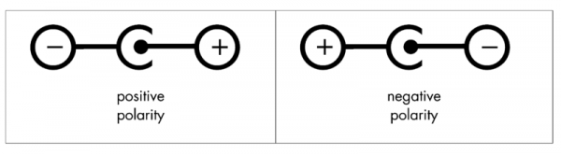](https://cdn.sparkfun.com/assets/2/f/6/e/0/5113f704ce395ffc7d000000.png)

*Common polarity diagrams for AC adaptors with barrel plugs. Positive polarity (tip positive, sleeve 0V) is most common. Diagram courtesy Wikipedia user*[*Three-quarter-ten*](http://commons.wikimedia.org/wiki/User:Three-quarter-ten)*.*

“Molex” Connectors

Most computer hard drives, optical drives, and other internal peripherals get power through what is typically called a “Molex” connector. To be more accurate, it’s a Molex series 8981 connector–Molex is actually the name of the company which initially designed this connector back in the 1950s–but common usage has denuded that fact somewhat.

Molex connectors are designed to carry a lot of current: up to 11A per pin. For projects where a lot of power may be needed–a CNC machine, for instance, or a 3D printer- a very common method for powering the project is to use a desktop PC power supply and connecting the various system circuits through Molex connectors.

The Molex connector is one where the male/female terminology is a bit odd. The female connector is usually found on the end of a cable, and it slips inside of a plastic shell which surrounds the male pins on the male connector. Usually, the connectors are press-fit only, and very, very tight–they are intended to be connected and disconnected only a few times and, as such, are a bad choice for systems where connections will frequently be changed.

[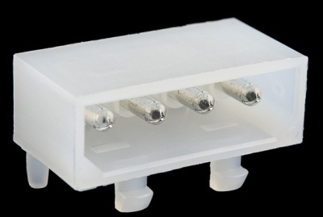](https://cdn.sparkfun.com/assets/5/d/e/d/6/51141ecdce395fba7d00000a.jpg)

[*Male Molex connector*](https://www.sparkfun.com/products/11297)*. The gender of the pins inside the connector is what signifies the gender of the connector as a whole.*

[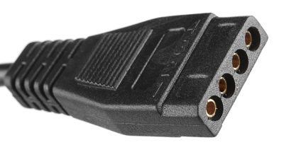](https://cdn.sparkfun.com/assets/f/d/5/f/2/51141ecdce395f547e000005.jpg)

*Female Molex connector on a*[*project power supply*](https://www.sparkfun.com/products/11296)*.*

IEC Connector

As with the Molex connector, this is a case where a generalized component name has come to be synonymous with a single, particular item. IEC connector usually refers to the power supply inlet which is commonly seen on desktop PC power supplies. Strictly speaking, that’s an [IEC 60320-1](http://en.wikipedia.org/wiki/Iec_connector) C13 (female) and C14 (male) connector.

[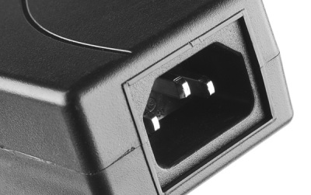](https://cdn.sparkfun.com/assets/e/1/f/b/4/51141f68ce395fbf7d00000b.jpg)

*C14 male IEC power inlet, on a*[*DC project power supply*](https://www.sparkfun.com/products/11296)*. Note that, as with the Molex connector, the gender of the connector is defined by the pins within the hood.*

[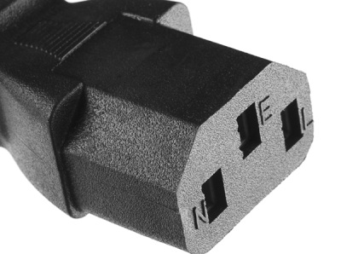](https://cdn.sparkfun.com/assets/9/6/1/7/0/51141f68ce395f7d7e00000c.jpg)

*C13 female IEC power connector, on a fairly standard*[*AC power supply cable*](https://www.sparkfun.com/products/11299)*. Cables with this end can be found all around the world, usually with the dominant local AC connector at the other end.*

IEC connectors are used almost exclusively for AC power input. The nice thing about using one on a project is that IEC-to-wall cables are extremely common *and* available with localized wall plugs for most international locations!

JST Connector

At SparkFun, we frequently refer to “2.0mm JST Connectors”. This is yet another generalization of a specific product- JST is a Japanese company which makes high-quality connectors, and our 2.0mm JST connector of choice is the PH series two-position polarized connector.

All of SparkFun’s single-cell lithium-polymer ion batteries come standard with this type of JST connector, and many of our boards include this connector (or a footprint for it) as a power supply input. It has the advantage of being compact, durable, and difficult to connect backwards. Another feature, which can be an advantage or a disadvantage, depending on how you look at it, is that the JST connector is wicked hard to disconnect (although a [carefully applied diagonal cutter](http://cdn.sparkfun.com/assets/f/e/2/a/b/5114447cce395f7a7a000005.jpg)can be helpful!) once it’s mated. While this makes it unlikely to fail during use, it also means that disconnecting the battery for charging can damage the battery connector.

[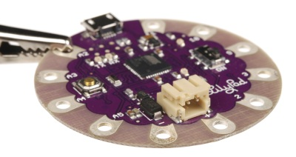](https://cdn.sparkfun.com/assets/9/6/8/5/c/51142023ce395ff633000005.jpg)

*2-Pin JST male connector on a*[*LilyPad Arduino USB*](https://www.sparkfun.com/products/11190)*board. Again, as with the Molex, the pins inside the hood determine the gender of the connector.*

[](https://cdn.sparkfun.com/assets/2/6/0/7/f/51141810ce395f4d7e000007.jpg)

[*Male and female 2-pin JST connectors*](https://www.sparkfun.com/products/9914)*.*

There are PH series connectors with more than two positions; SparkFun even sells them. However, our most frequent application is for the 2-position battery connection.

Pin Header Connectors

Pin header connectors comprise several different means of connection. Generally, one side is a series of pins which are soldered to a PCB, and they can either be at a right-angle to the PCB surface (usually called “straight”) or parallel to the board’s surface (confusingly referred to as “right-angle” pins). Such connectors come in a variety of pitches, and may have any number of individual rows of pins.

[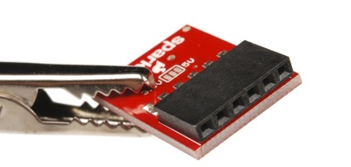](https://cdn.sparkfun.com/assets/7/4/e/2/f/511420f6ce395f157b000003.jpg)

*Right-angle female header pin connection on an*[*FTDI basic*](https://www.sparkfun.com/products/9716)*board.*

The most commonly seen pin headers are .1" single or double row connectors. These come in [male](https://www.sparkfun.com/products/116) and [female](https://www.sparkfun.com/products/115)versions, and are the connectors used to connect Arduino boards and shields together. Other pitches are not uncommon; for instance, the [XBee wireless module](https://www.sparkfun.com/products/8664) uses a [2.0mm pitch](https://www.sparkfun.com/products/8272) version of the same connector.

[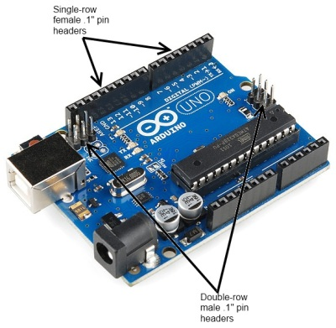](https://cdn.sparkfun.com/assets/6/b/4/9/c/51142177ce395f9a7e000005.jpg)

*.1" pin header connectors, male and female, on an Arduino Uno board.*

A common variation on this part is a “machine pin” version. While the normal version is formed out of stamped and folded sheet metal, machine pin connectors are formed by tooling the metal into the desired shape. The result is a more robust connector, with a better joint and longer life, making it somewhat more expensive.

[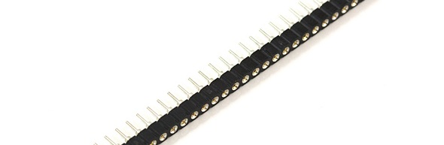](https://cdn.sparkfun.com/assets/d/4/8/d/a/5114022cce395f547e000003.jpg)

[*Female machine pin headers*](https://www.sparkfun.com/products/743)*. Note that these are designed to be snapped apart into smaller sections, while standard .1" female header pin connectors are not. It’s also important to note that not all non-machine pin header connectors will mate with the machine pin variety.*

Cables made to connect to these pin headers are usually one of two types: individual wires with **crimp** connectors on them or ribbon cables with **insulation displacement** connectors. These can simply be clamped onto the end of a ribbon cable, which creates a connection to each one of the conductors in the ribbon cable. Generally, cables are only available as female gender and expect a male pin to mate with.

[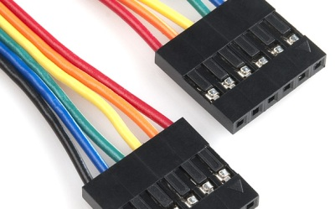](https://cdn.sparkfun.com/assets/c/d/6/9/4/511421f8ce395f687e000007.jpg)

[*Six-position crimp-type cable*](https://www.sparkfun.com/products/10366)*. Each wire is individually stripped, a connector crimped to it, and then the connectors are inserted into the plastic frame.*

[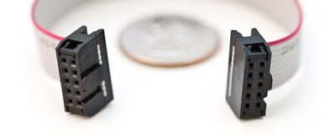](https://cdn.sparkfun.com/assets/a/2/c/8/a/5114225fce395fe301000007.jpg)

[*2x5 insulation displacement connectors (IDC) on a ribbon cable*](https://www.sparkfun.com/products/8535)*. This type of cable can be quickly assembled because it does not require stripping of individual connectors. It also has polarizing tabs on each end, to prevent incorrect insertion in the mating board-side connector.*

Temporary connectors

Screw Terminals

In some cases, it may be desirable to be able to connect bare, unterminated wire to a circuit. Screw terminals provide a good solution for this. They are also good for situations in which a connection should be capable of supporting multiple different connecting devices.

The downside of screw terminals is that they can come undone fairly easily, leaving a bare wire waving around in your circuit. A small dab of hot glue can address this without being too difficult to remove later.

Screw terminals are typically designed for a narrow range of wire gauges, and wires that are too small can be as big a problem as wires that are too big. SparkFun carries two types of screw terminal–a .1" pitch version and a 3.5mm version. Most screw terminals are highly modular, and they can easily be extended at the same pitch by simply connecting two or more smaller sections together.

[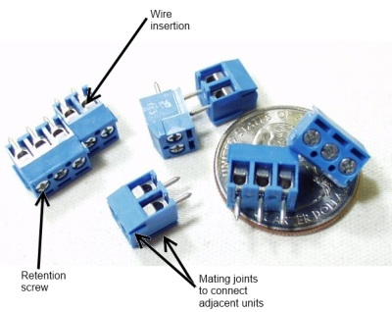](https://cdn.sparkfun.com/assets/d/6/c/4/a/511422cdce395feb01000003.jpg)

-> [*3.5mm pitch screw terminals*](https://www.sparkfun.com/products/8235)*, showing the insertion point of the wire to be connected, the retention screw which holds the wire in place, and the modular connectors on the sides of the individual units allowing multiple pieces to be ganged together.* <-

Banana Connector

Most pieces of power test equipment (multimeters, power supplies) have a very simple connector called a “banana jack” on it. These mate to “banana plugs”, crimped, sprung metal plugs, meant to make a single power connection. They are frequently available in a stackable configuration and can be easily connected to any type of wire. They are capable of carrying several amps of current and are inexpensive.

[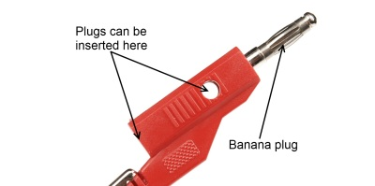](https://cdn.sparkfun.com/assets/8/c/a/2/7/5114231ece395f7e7e000002.jpg)

[*Stackable banana plug*](https://www.sparkfun.com/products/507)*. Note that there are two different ways to plug in an additional banana plug.*

[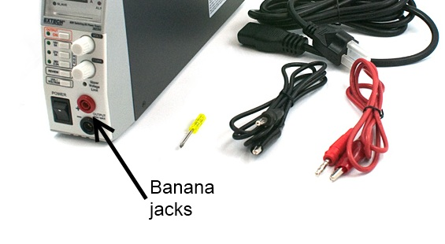](https://cdn.sparkfun.com/assets/9/5/6/0/3/5113f12fce395fc37e000000.jpg)

[*Extech variable bench supply*](https://www.sparkfun.com/products/9291)*with banana jacks on the front.*

Alligator Clip

Named for obvious reasons, alligator clips are good for test connections to posts or bare wires. They tend to be bulky, easily cause shorts to nearby bare metal, and have a reasonably poor grip that can be easily compromised. They are primarily used for low-cost connections during debugging.

[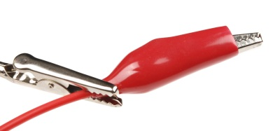](https://cdn.sparkfun.com/assets/4/b/e/5/4/5114236dce395fa17e000006.jpg)

*A*[*“third hand” tool*](https://www.sparkfun.com/products/9317)*, which uses alligator clips to hold work pieces, holding a*[*wire terminated with an alligator clip for electrical test*](https://www.sparkfun.com/products/509)*. Note the plastic boot surrounding the alligator clip, to make it less likely to short to other connections.*

IC Clip (or IC Hook)

For more delicate probing operations, there are a variety of IC clips on the market. These are sized to allow a user to clip them onto the pins of an IC without contacting adjacent pins; some of them are delicate enough to be clipped onto even fine-pitched SMD component legs. These smaller clips can be found on [logic analyzers](https://www.sparkfun.com/products/8938) as well as [test leads](https://www.sparkfun.com/products/501), which are great for prototyping or troubleshooting circuits.

[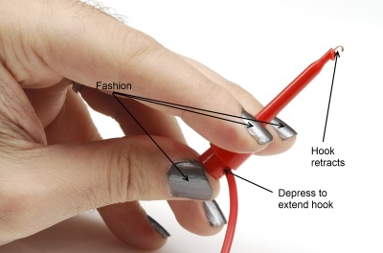](https://cdn.sparkfun.com/assets/c/5/5/d/f/511423e4ce395fae7e000005.jpg)

*A*[*large IC clip on the end of a wire*](https://www.sparkfun.com/products/506)*. This clip is still small enough to be connected to a single leg on a through-hole chip without causing a problem for adjacent pins.*

Other Connectors

RJ-type Modular Connectors

**Registered jack** connectors are standard for telecommunications equipment into a local exchange. The names one normally hears associated with them (RJ45, RJ12, etc) are not necessarily correct, as the RJ designator is a based on a combination of the number of positions, the number of conductors actually present, and the wiring pattern. For example, while the ends of a standard ethernet cable are usually referred to as “RJ45”, RJ45 actually implies not only an 8 position, 8 conductor modular jack, it also implies that it is wired for ethernet.

These modular connectors can be very useful, since they combine ready availability, multiple conductors, moderate flexibility, low cost, and moderate current carrying capacity. While not originally intended to deliver a great deal of power, these cables can be used to deliver data and a couple of hundred milliamps from one device to another. Care should be taken to ensure that jacks provided for applications like this are not connected to conventional ethernet ports, as damage will result.

[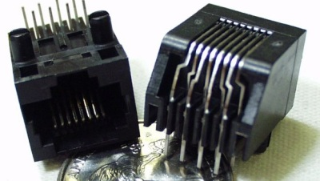](https://cdn.sparkfun.com/assets/9/b/6/b/4/51142492ce395f8301000005.jpg)

*A standard 8p8c (8-position, 8-conductor)*[*“RJ45” modular jack*](https://www.sparkfun.com/products/643)*. Be aware that if you intend to use this type of jack to pass DC signals and power, you must avoid using connectors with*[*built-in signal transformers*](https://www.sparkfun.com/products/8534)*.*

D-sub Type Connectors

Named for the shape of their shell, D-subminiature connectors are a classic standard in the computing world. There are four very common varieties of this connector: DA-15, DB-25, DE-15, and DE-9. The pin number indicates the number of connections provided, and the letter combination indicates the size of the shell. Thus, DE-15 and DE-9 have the same shell size, but a different number of connections.

[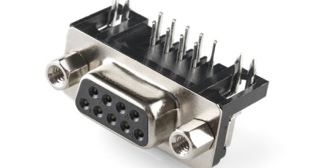](https://cdn.sparkfun.com/assets/6/5/6/b/8/51142492ce395fe901000004.jpg)

[*Female DE-9 board-mount connector*](https://www.sparkfun.com/products/429)*. Gender is defined by the pins or sockets associated with each signal, not the connector as a whole, making this connector female despite the fact that it effectively inserts into the shell of the mating connector.*

DB-25 and DE-9 are the most useful to the hardware hacker; many desktop computers still include at least one DE-9 serial port, and often one DB-25 parallel port. Cables terminated with [DE-9](https://www.sparkfun.com/products/65?) and [DB-25](https://www.sparkfun.com/products/64?) connectors are widely available, too. As with the modular connector above, these can be used to provide power and point-to-point communications between two devices. Again, since the common usage of these cables does *not* include power transmission, it is very important that any repurposing of the cables be done cautiously, as a non-standard device plugged into a standard port can easily cause damage.

Ref. Sparkfun.com

Wikipedia

**STEP UP AND STEP DOWN CONVERTERS**

Boost Converter(Step Up Converter):

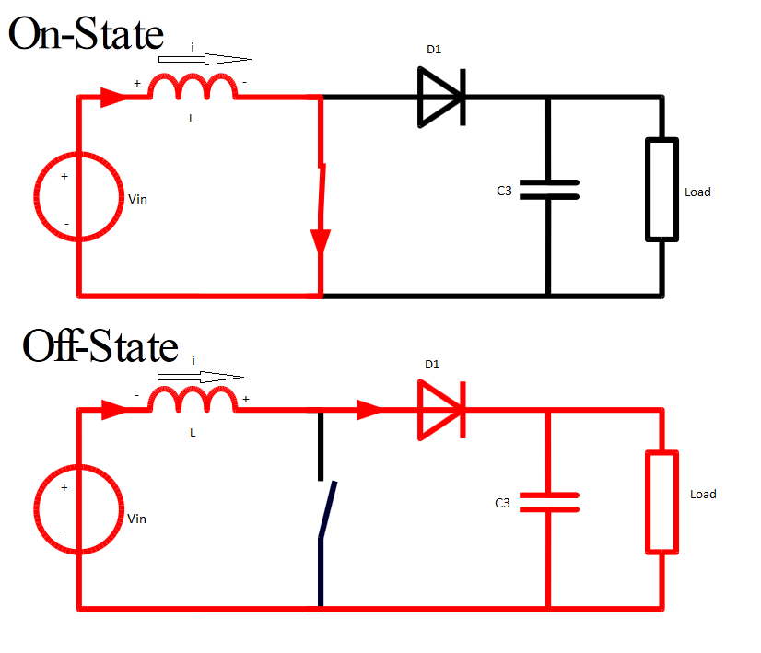

Working principle

A Boost converter steps up a DC voltage from the input to the output. The circuit operation depends on the conduction state of the MOSFET(the switch can be Mosfet ,BJT, or any other type of switch):

* **On-state**: The current through the inductor increases linearly and the diode blocks.
* **Off-state**: Since the current through the inductor can not abruptly change the diode must carry the current so it commutates and begins conducting. Energy is transferred from the inductor to the capacitor resulting in a decreasing inductor current. During steady state the circuit is said to operate:  
  + in *discontinuous conduction*mode if the inductor current reaches zero and
  + in *continuous conduction*mode if the inductor current never reaches zero.

The circuit has two limits of operation. For a PWM duty cycle D ➝ 0 the output voltage equals Vin, and for D ➝ 1 the output voltage grows toward infinity. In between those limits the output voltage in continuous conduction mode is given by: Vout = Vin/(1-D).(theo.)

Note that the parallel combination of inductor and capacitor as shown above acts as a second order low pass filter reducing the voltage ripple at the output.

Buck Converters

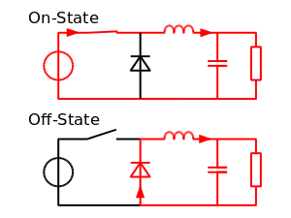

Working principle

A Buck converter steps down a DC voltage from the input to the output. The circuit operation depends on the conduction state of the MOSFET:

* **On-state**: The current through the inductor increases and the diode blocks.
* **Off-state**: Since the current through the inductor can not abruptly change the diode must carry the current so it commutates and begins conducting. Energy is transferred from the inductor to the capacitor resulting in a decreasing inductor current. During steady state the circuit is said to operate:  
  + in *discontinuous conduction* mode if the inductor current reaches zero and
  + in *continuous conduction* mode if the inductor current never reaches zero.

The circuit has two limits of operation. For a PWM duty cycle D ➝ 0 the output voltage equals zero, and for D ➝ 1 the output voltage equals Vin. In between those limits the output voltage in continuous conduction mode is given by: Vout = D **·**Vin.(theo.)

Note that the parallel combination of inductor and capacitor as shown above acts as a second order low pass filter reducing the voltage ripple at the output.

Buck Boost Converter

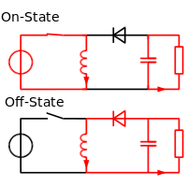

Working principle

A Buck-Boost converter transforms a positive DC voltage at the input to a negative DC voltage at the output. The circuit operation depends on the conduction state of the MOSFET:

* **On-state**: The current through the inductor increases and the diode is in blocking state.
* **Off-state**: Since the current through the inductor can not abruptly change the diode must carry the current so it commutates and begins conducting. Energy is transferred from the inductor to the capacitor resulting in a decreasing inductor current and a voltage across the resistor with the opposite polarity compared to Vin. During steady state the circuit is said to operate:  
  + in *discontinuous conduction* mode if the inductor current reaches zero and
  + in *continuous conduction* mode if the inductor current never reaches zero.

The circuit has two limits of operation. For a PWM duty cycle D ➝ 0 the output voltage equals zero, and for D ➝ 1 the output voltage grows toward negative infinity. In between those limits the output voltage in continuous conduction mode is given by: Vout = -D/(1-D) **·**Vin.(theo.)

Note that the parallel combination of inductor and capacitor as shown above acts as a second order low pass filter reducing the voltage ripple at the output.

**PBL Project As PCB**

My PBL project was obstacle detection using IR Led and Photodiode

SCHEMATIC CIRCUIT:

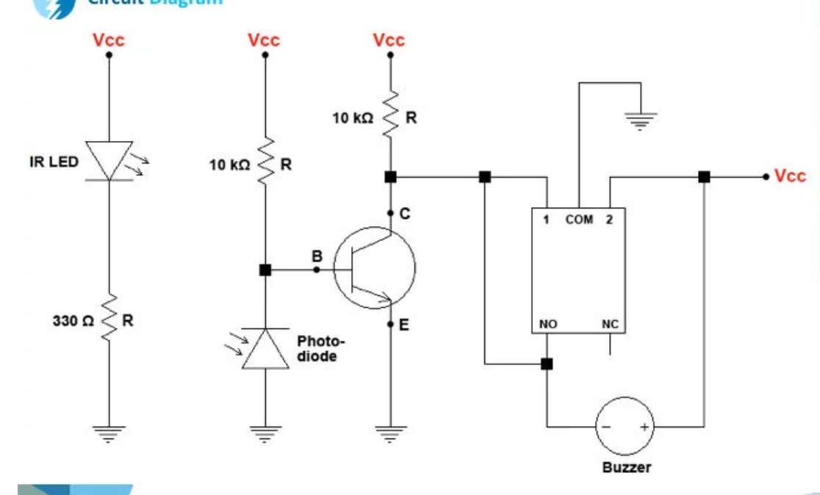

It included two circuits , Transmission and Receiver Circuits. Their Breadboard View and PCB designs are as follows:

Transmitter Circuit:

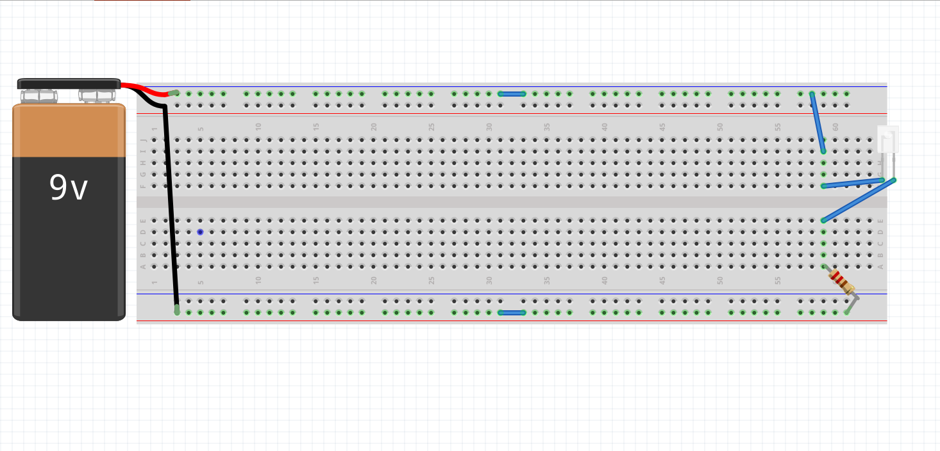

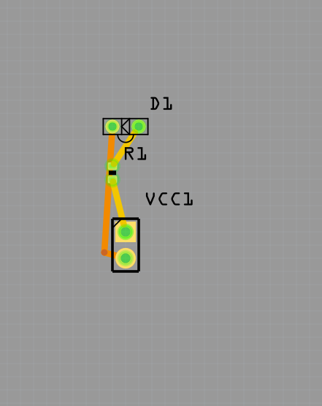

Receiver Circuit:

